Meta Description:
1)Underestimating Cultural Nuances 2) Neglecting the Role of Digital Presence 3) One-Size-Fits-All Marketing Strategies 4) Overlooking Competitor Analysis

7 Costly Mistakes to Avoid When Positioning Your Brand in Dubai

It can be a great experience to position your brand in Dubai.
This city is indeed one of the most strategic business, cultural, and innovation cities in the world.
Without adequate planning and strategizing, it is impossible to position a brand in the competitive environment of Dubai.
The competition and cultural factors are other issues that could act as challenges when you are going to position your brand in Dubai, UAE.
You don’t have to worry about any of such factors when you get Brand Positioning Services Dubai from a reliable agency.
In this blog, we have highlighted the seven mistakes you should avoid when positioning your brand in Dubai and how a right agency helps you in it.
By taking into consideration all these mistakes, the success of your brand in Dubai is guaranteed.

Mistake 1: Underestimating Cultural Nuances
Dubai is a multicultural city par excellence. This diversity gives rise to culture sensitivity issues because most of the population of Dubai comes from different countries with different norms and cultures.
Failure to consider such aspects results in mistakes that may have an impact on your branding and business outcomes. By getting Brand Positioning Service UAE from the right agency, you can easily deal with issues related to cultural nuances.

Learn About Dubai's Multicultural Landscape:
Currently, there are over 200 nationalities living in the Emirate of Dubai.
Due to this diversity, a blend of cultures along with diverse consumer trends converge with locally preservative flavors.
Lack of understanding of the cultural difference is therefore a fatal mistake that your brand in Dubai can’t afford to make.

Importance of Understanding Local Customs and Traditions:
Proper understanding about the ethics of the country before engaging in business activities is very important as it helps to foster a good image of the company.
For instance, it can help to improve your brand image and the chance of being accepted by the local consumers because of embracing their religion and festivals.

Mistake 2: Neglecting the Role of Digital Presence
Today, digital media in Dubai is growing significantly due to high internet connectivity.
Lack of paying attention towards the practice negatively impacts brand visibility and consequently its interaction with the society.
Here are some steps you can take to avoid neglecting the role of digital presence:

Understand Dubai's Digital Landscape:
One of the signs that residents of Dubai are active on the internet is that the internet penetration rate is relatively high compared to other countries in the world.
This makes the utilization of digital marketing imperative in your marketing approach to the targeted customers.

Importance of a Strong Online Presence:
Being active in the online environment increases consumer engagement, improves advocacy of the brand message, and the creation of a sense of credibility. It offers an opportunity to communicate with customers and receive their feedback as well.
You don’t have to worry about your brand online presence when you have the right brand positioning agency by your side.

Consequences of Ignoring Social Media and Online Engagement:
Companies that do not incorporate social media may lose the chance of engaging with their clients and customers in various ways. A recent research on consumers' behaviors in Dubai reveals that companies that are more active on social media platforms such as Instagram, Twitter, and Facebook are able to generate more sales.
Lack of activities on the web front may result in low brand awareness and sales. You can work on both issues simultaneously by hiring the right Brand Positioning Consultant agency in Dubai.

Mistake 3: One-Size-Fits-All Marketing Strategies
The diversification of marketing approaches of a product or a service is pertinent to the Dubai market.
That’s why, the use of a generic strategy will lead to the development of an ineffective campaign, as well as cost and time wastage.

Why Opt for Tailored Marketing Approaches?
Using the one-size-fits-all approach in addressing consumers in Dubai does not provide expected results as the market of Dubai holds a rather diversified nature concerning consumer preferences.
Segmentation of the target population implies that you come up with the best way to convince each segment about the message that you are passing across.

Advantages of Localizing Content and Offers:
Targeting consumers within your region makes your brand more appealing as it will be seen as relevant to this market. It indicates that, as a provider, you respect their cultural and linguistic differences and backgrounds.

Mistake 4: Overlooking Competitor Analysis
An important step in claiming your brand’s niche in the market is to have a proper understanding about the market competitors. Not knowing the competitors means that there will inevitably be blind areas.

Importance of Understanding the Competitive Landscape:
Understanding competitors’ activity level is very important because it provides a clue into the opportunities that are available out there. It also enables your brand to advertise your products and services in a way that offers the customers something they cannot find with other companies.

Insights into What Competitors Are Doing Right and Wrong:
Studying competitors allows to replicate successful practices and avoid mistakes. It can also be advantageous for you to learn about what not to do in case you find yourself in a similar situation.

Strategies for Conducting Effective Competitor Analysis:
Do proper research on competitors through the observation of their marketing activities, customers’ reactions to it, as well as their position on the market.
Social media and other analytical instruments can prove effective in interpreting the market reports.

Mistake 5: Failing to Build Relationships with Local Influencers
Influencer marketing works very effectively in Dubai due to the tech-savvy nature of the audience. Neglecting local influencers entails overlooking important opportunities that point to brand endorsement and market coverage.

Influencer Marketing Landscape in Dubai:
There is a strong market of influencers in the Dubai market with many local and regional influencers having huge followings. Working with those personalities can help in spreading the intended message of the brand universally.

Benefits of Partnering with Local Influencers:
Local influencers are influential and trustworthy personalities to your brand. They have rich experience, especially when it comes to cultural factors, and have what it takes to sell your products to your clients.

Tips for Identifying and Approaching the Right Influencers:
Conclusively, find out key opinion leaders whose values are in harmony with your brand. Get in touch with these influencers through the social platforms. Additionally, propose giveaway offers of unique products or services in return for spreading the word about one’s enterprise.

Mistake 6: Ignoring Legal and Regulatory Requirements
There are certain laws and regulations that govern the business environment of Dubai. Failure to observe these may result in legal implications, and an adverse impact in the perception of the brand.
Business laws implemented in Dubai are quite rigorous and range from that of advertising to protection of the buyer. Compliance is important in order not to have hitches while operating within this kind of market.

Importance of Compliance:
Non-compliance can lead to prosecution, litigation and severe damage in terms of corporate image.
Through proper compliance to regulations, your brand can establish and maintain a good image and show your consumers that your brand is sincere in its business practices.

Steps for Ensuring Legal Alignment in Brand Activities:
To deal with the legal aspects, it is recommended to turn to lawyers who have knowledge about the legislation in Dubai.
It is recommended to immerse yourself in researching legal updates because all product/media content and customer-facing business processes must adhere to the laws of Dubai.

Mistake 7: Not Adapting to Economic and Market Changes
Dubai’s economy is to some extent volatile and constantly evolving, where customer preferences and tendencies tend to shift often. It outlines that firms which will not innovate will be left obsolete.

Analysis of Dubai's Rapidly Changing Economic Conditions:
Some major factors that affect the economy of Dubai include factors such as tourism, properties, and crude oil. It would be easier to manage them if the dynamics of the game were monitored from time to time so that you could adapt as necessary.

Importance of Agility and Responsiveness in Branding Strategies:
The rationale behind being agile is that in today’s competitive market, it is more strategic to adapt to market changes and consumers’ needs. This flexibility is crucial in order for the brand to keep up with the competition.

Strategies for Staying Ahead of Market Trends and Consumer Preferences
This should be done frequently to help the organization get an insight of the growing trends out in the market. Communicate with the target audience to get their reactions, opinions, and ideas, and expect to have to adapt your strategies at any given time.

Conclusion:
The opportunities that Dubai has given your brand are vast, therefore, it bears potential threats as well. By avoiding these seven costly mistakes, you can easily open the door to a lot of new opportunities in the market of Dubai.
By acknowledging cultural differences, establishing an online presence, creating products relevant to the culture, analyzing market competitors, involving local opinion leaders, adhering to laws, and being prepared for change in the economy, you can position your brand in a better way. To avoid all these mistakes, you need reliable Brand Positioning Services Dubai from a reliable agency that knows how to make things happen. In this way, you can position your brand above your competitors in the most effective way.
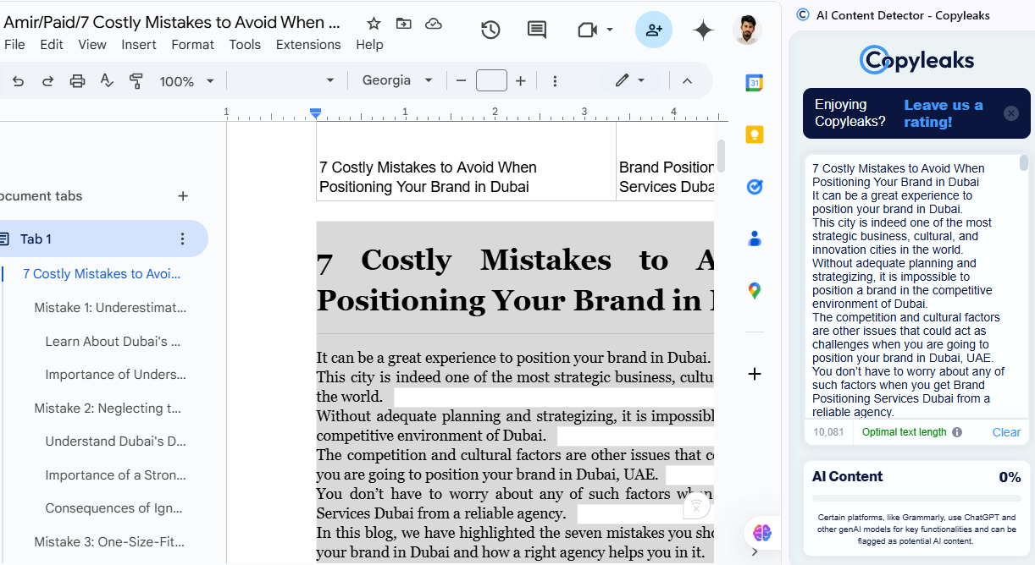
https://coda.io/@kaizen-eithan/7-costly-mistakes-to-avoid-when-positioning-your-brand-in-dubai

